Hotel Room Reservation Form
-------------------------------------------------------------------------------------------------------------------------------------------------
Warm greetings from Shilla Stay Gwanghwamun
SCET 2026 Reservation
Feb 25 (Wed) ~ March 5 (Thu) 2026
In order to secure a room at Hotel, please attach this page and
E-mail to reservation center with the appropriate information no later than Feb 4th (Wed), 2026.
The reservation confirmation will be out E-mail within 48 hours after receiving this form.
Central Reservation Center: Phone: +82-2-2230-0700 / E-mail: gwanghwamun@shillastay.com
--------------------------------------------------------------------------------------------------------------------------------------------------
Personal Information
Last Name
First Name
Phone Number
Email Address

Accommodation Information

Hotel Name | Room Type | Rack Rate | Special Rate |  | Date / Period
Hotel Name | Room Type | Rack Rate | Room only | with 1 PAX Breakfast | Check-In | Check-Out | Daily  Breakfast  (O/X)
Shilla Stay  Gwanghwamun | Standard Double □  Hollywood Double □  Standard Twin □  (Sun-Thu) | KRW 600,000 | KRW 154,000 | KRW 173,800
Shilla Stay  Gwanghwamun | Standard Double □  Hollywood Double □  Standard Twin □  (Fri) | KRW 600,000 | KRW 187,000 | KRW 206,800
Shilla Stay  Gwanghwamun | Standard Double □  Hollywood Double □  Standard Twin □  (Sat) | KRW 600,000 | KRW 198,000 | KRW 217,800
Shilla Stay  Gwanghwamun | Standard Double □  Hollywood Double □  Standard Twin □  (Sun, Mar 1st) | KRW 600,000 | KRW 231,000 | KRW 250,800
Shilla Stay  Gwanghwamun | Standard Double □  Hollywood Double □  Standard Twin □  (Mon, Mar 2nd) | KRW 600,000 | KRW 209,000 | KRW 228,800
Shilla Stay  Gwanghwamun | _______________  (Sun-Thu) | - | KRW_________ | KRW_________
Shilla Stay  Gwanghwamun | ______________  (Fri) | - | KRW_________ | KRW_________
Shilla Stay  Gwanghwamun | ______________  (Sat) | - | KRW_________ | KRW_________
Shilla Stay  Gwanghwamun | ______________  (Sun, Mar 1st) | - | KRW_________ | KRW_________
Shilla Stay  Gwanghwamun | ______________  (Mon, Mar 2nd) | - | KRW_________ | KRW_________
* The above rates are 10% tax included.
* Except Standard Type, Please check the room type and price on the rate table below and write it down yourself.
* The breakfast discount is applied only when you make a reservation at the time the room reservation is made.
* In case of NO SHOW, one night charge will be charged on your guaranteed card.
* Cancellation within 24 hours of arrival will be subject to one night’s charge will be forfeited on your guaranteed card.
* The special rate reservation period is until Wednesday, Feb 4th. Please contact the reservation center separately after Feb 4th.
* Include free internet & Wi-Fi & fitness club access .
* Our check in time is 15:00 PM and check out time is 12:00 PM. In case of early check-in or late check-out, extra cost will be charged upon a time. (Advance inquiry required.)

Guaranteed Payment Information

□ Amex □ Diners □ Master □ Visa □ JCB | 4 digit number for AMEX:
Card Number: | Expiry Date:

Please refer to the rate table below.
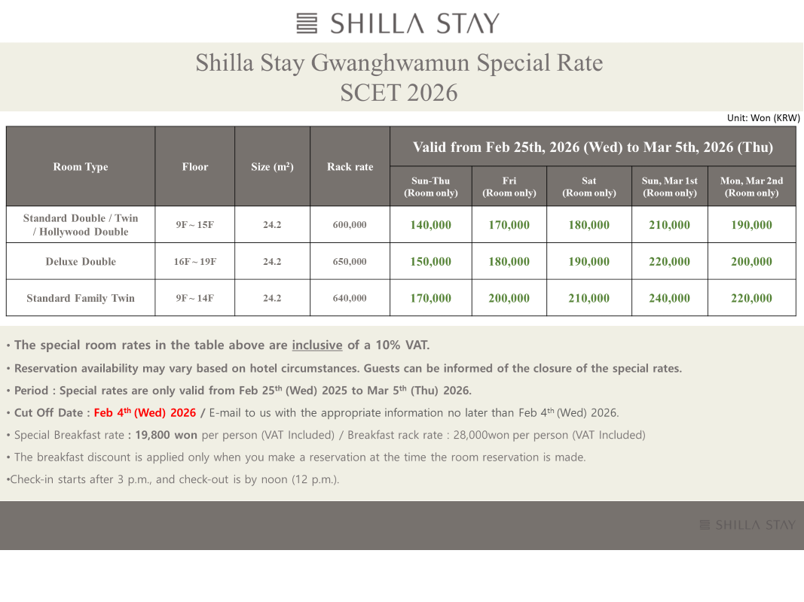

Please fill out your special requests

____________________________________________________________________________________________________________________________________________________________________________________

